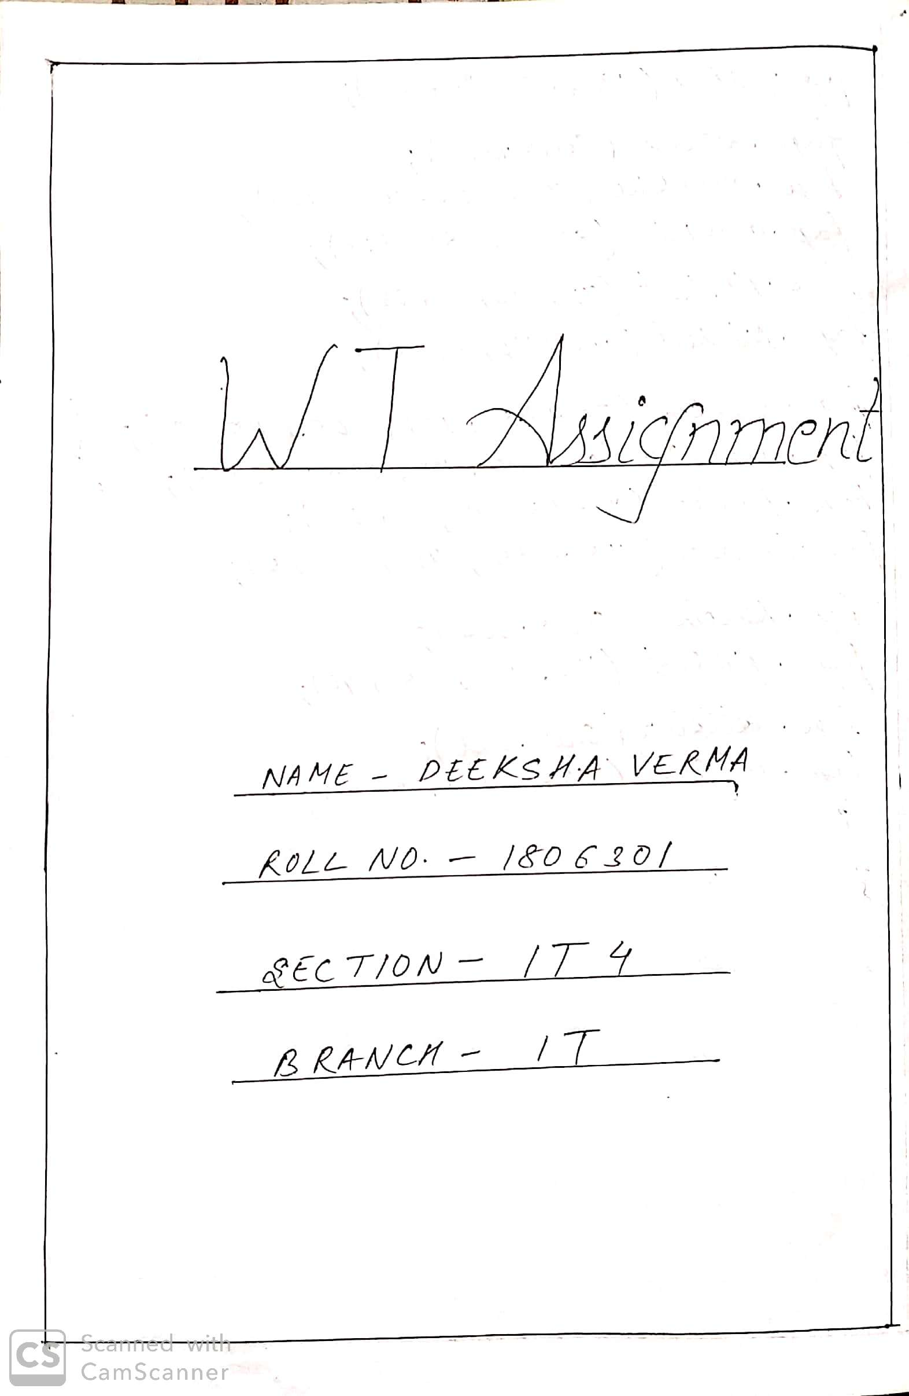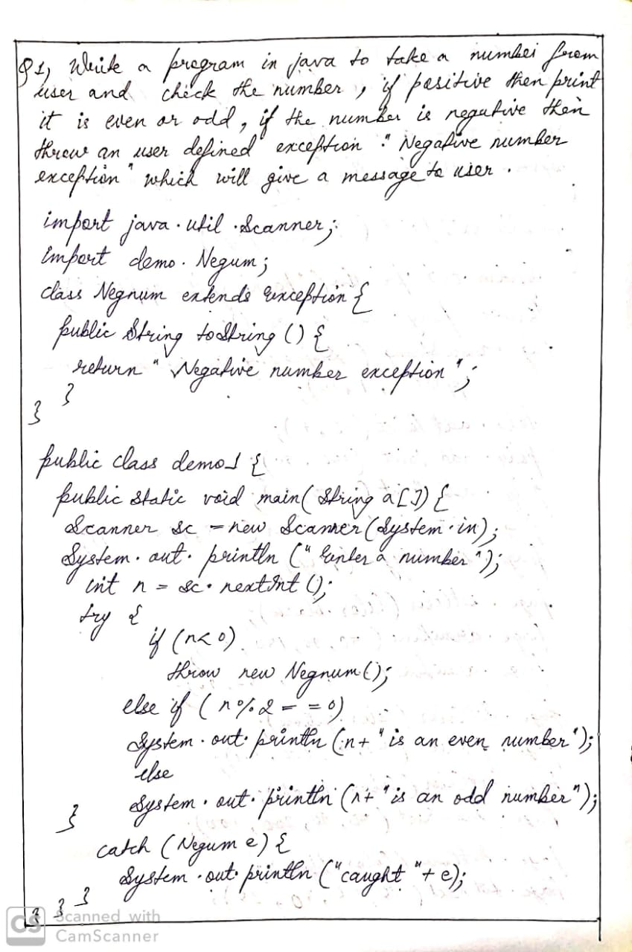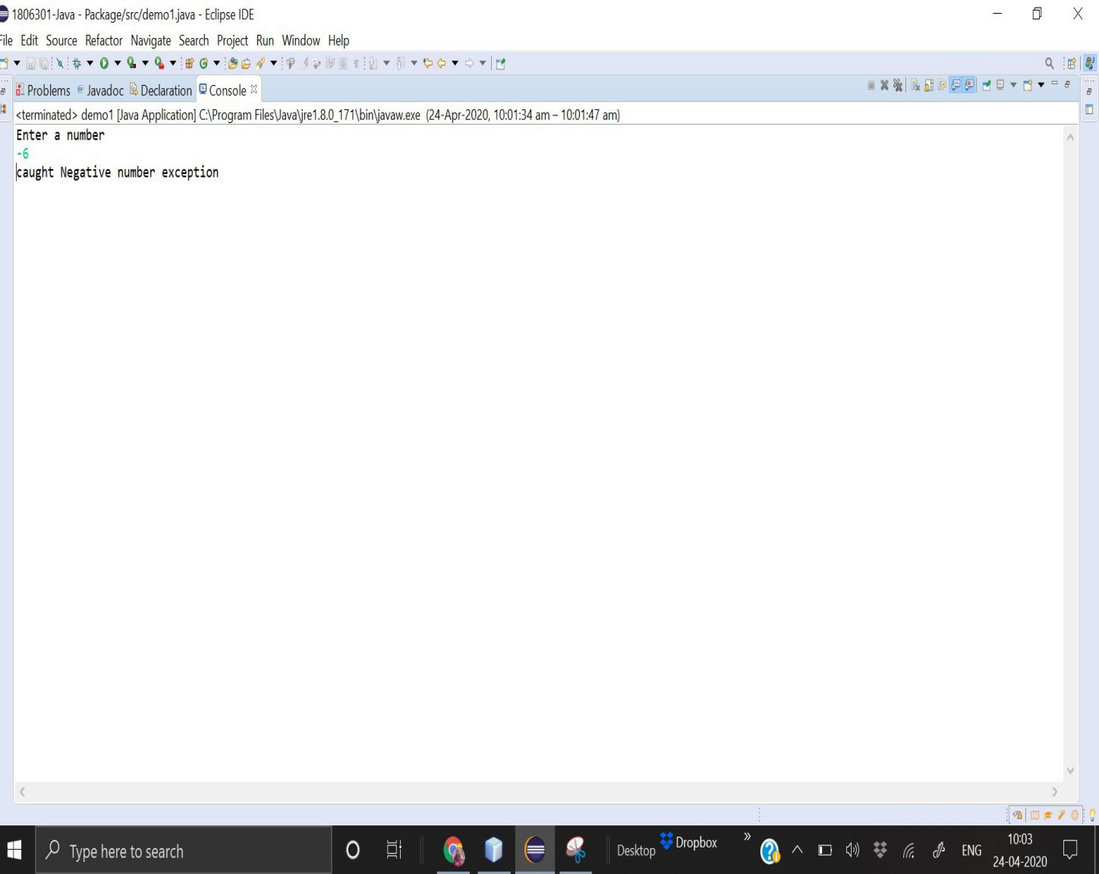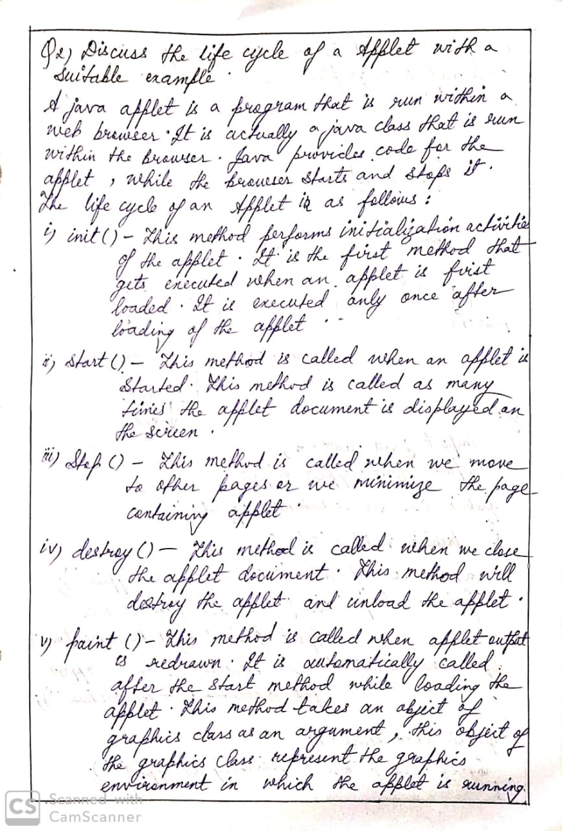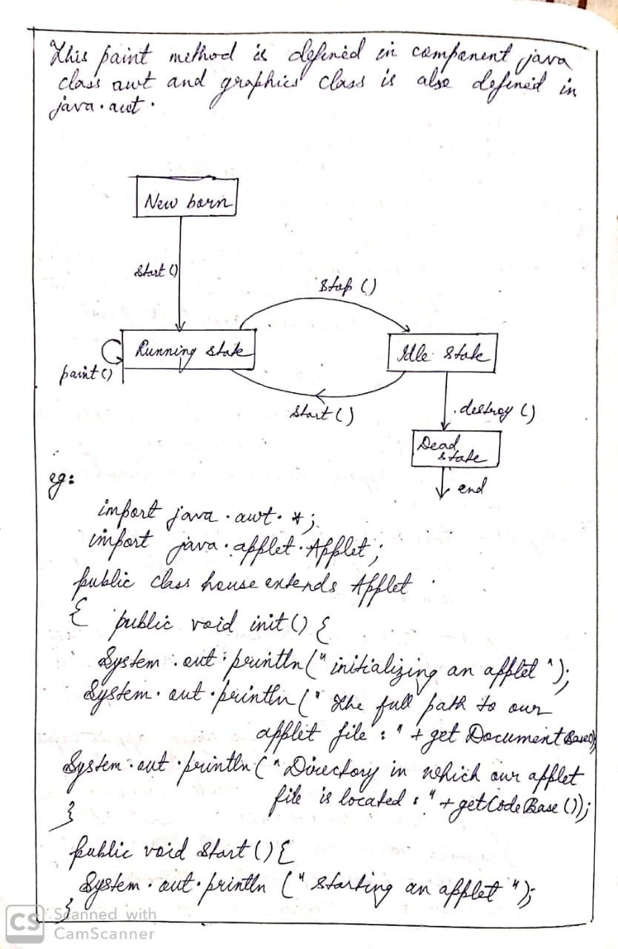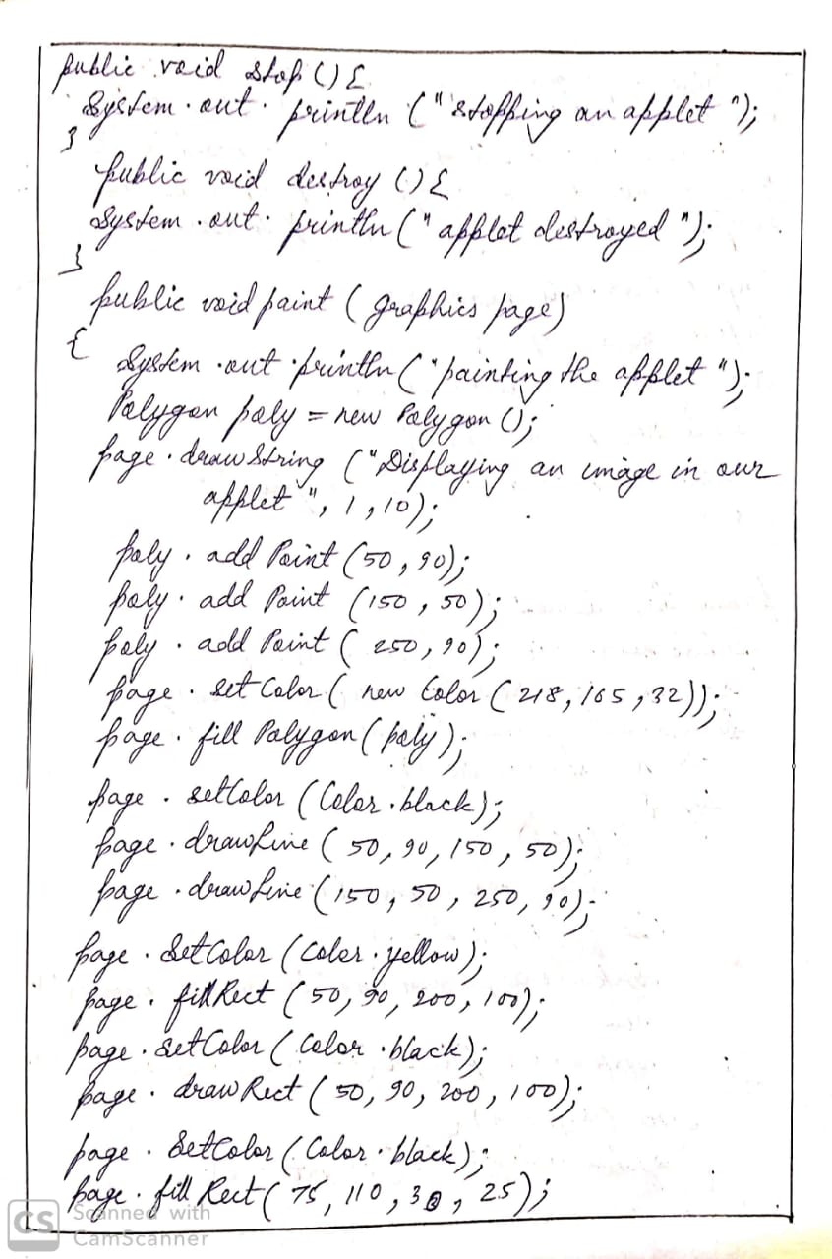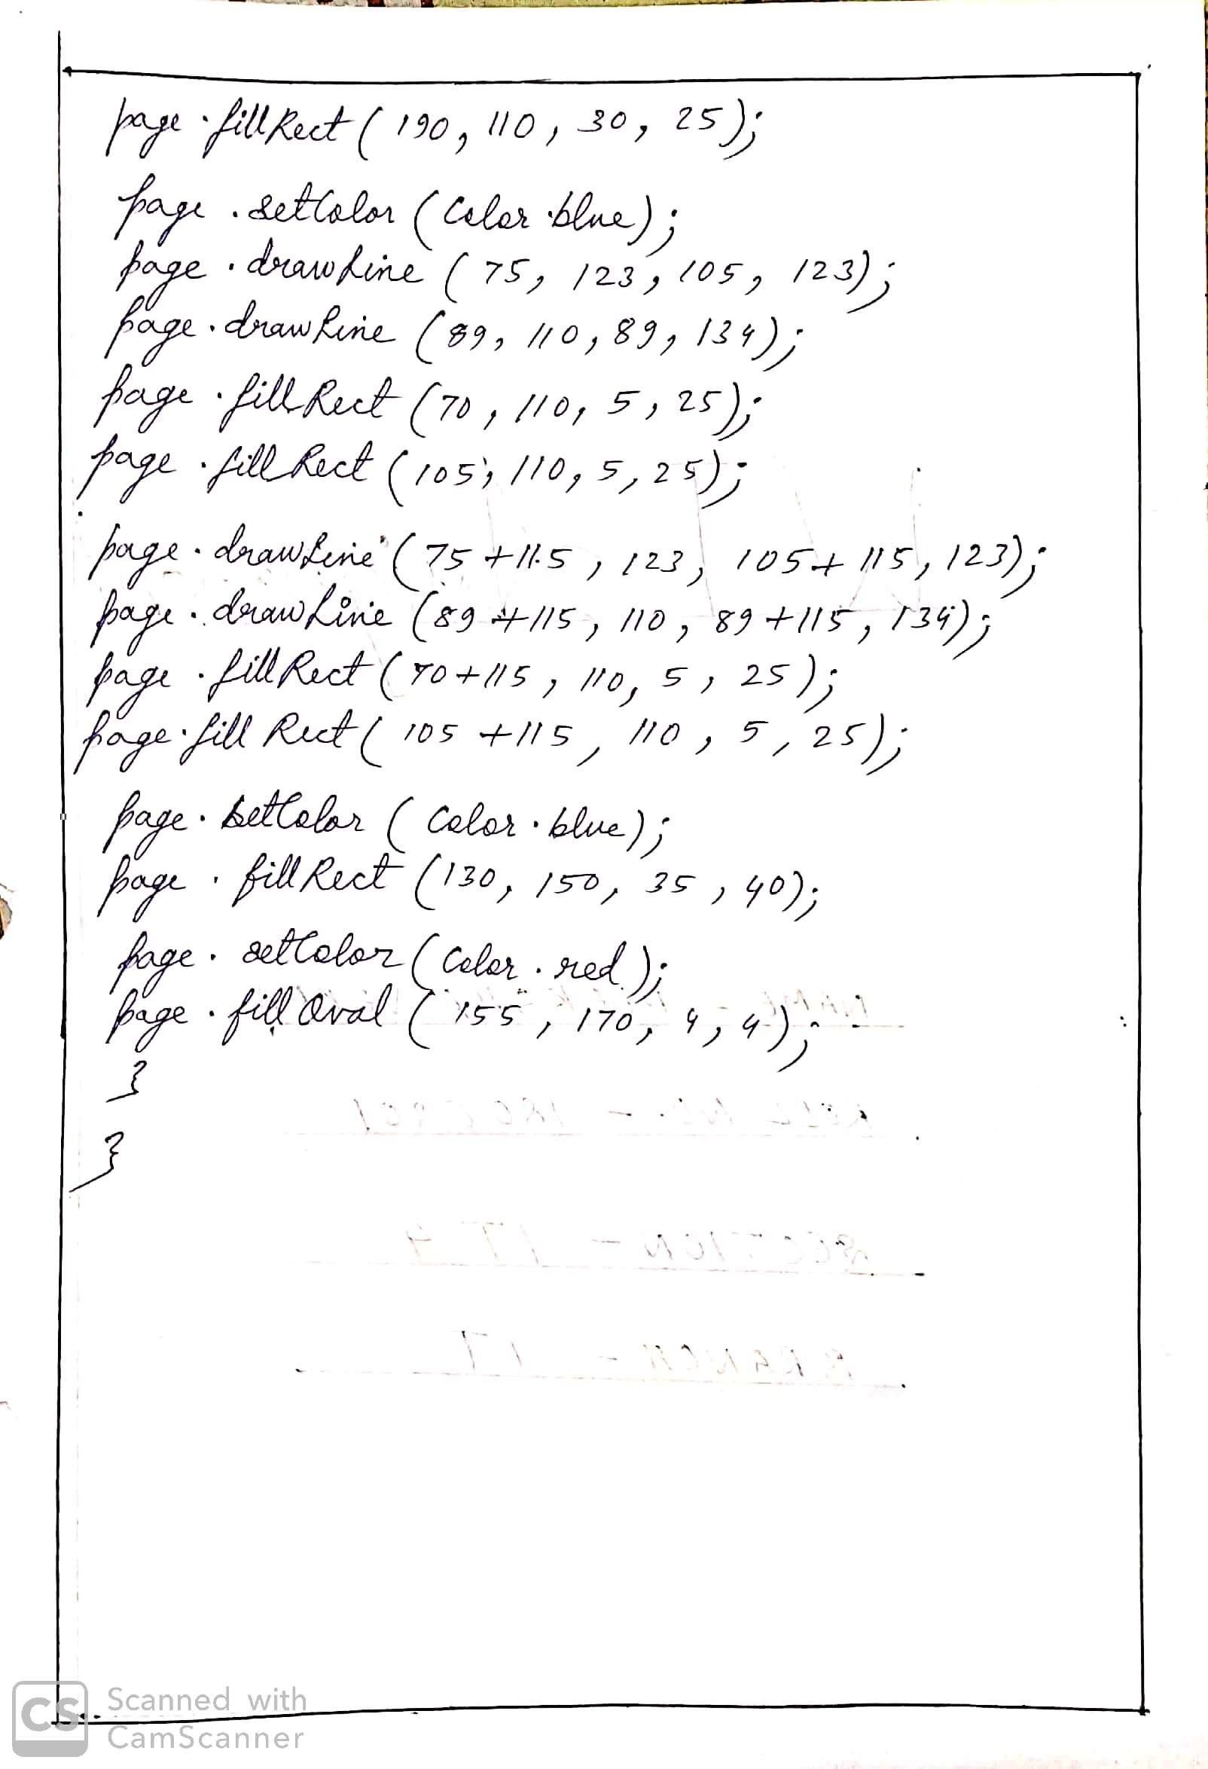

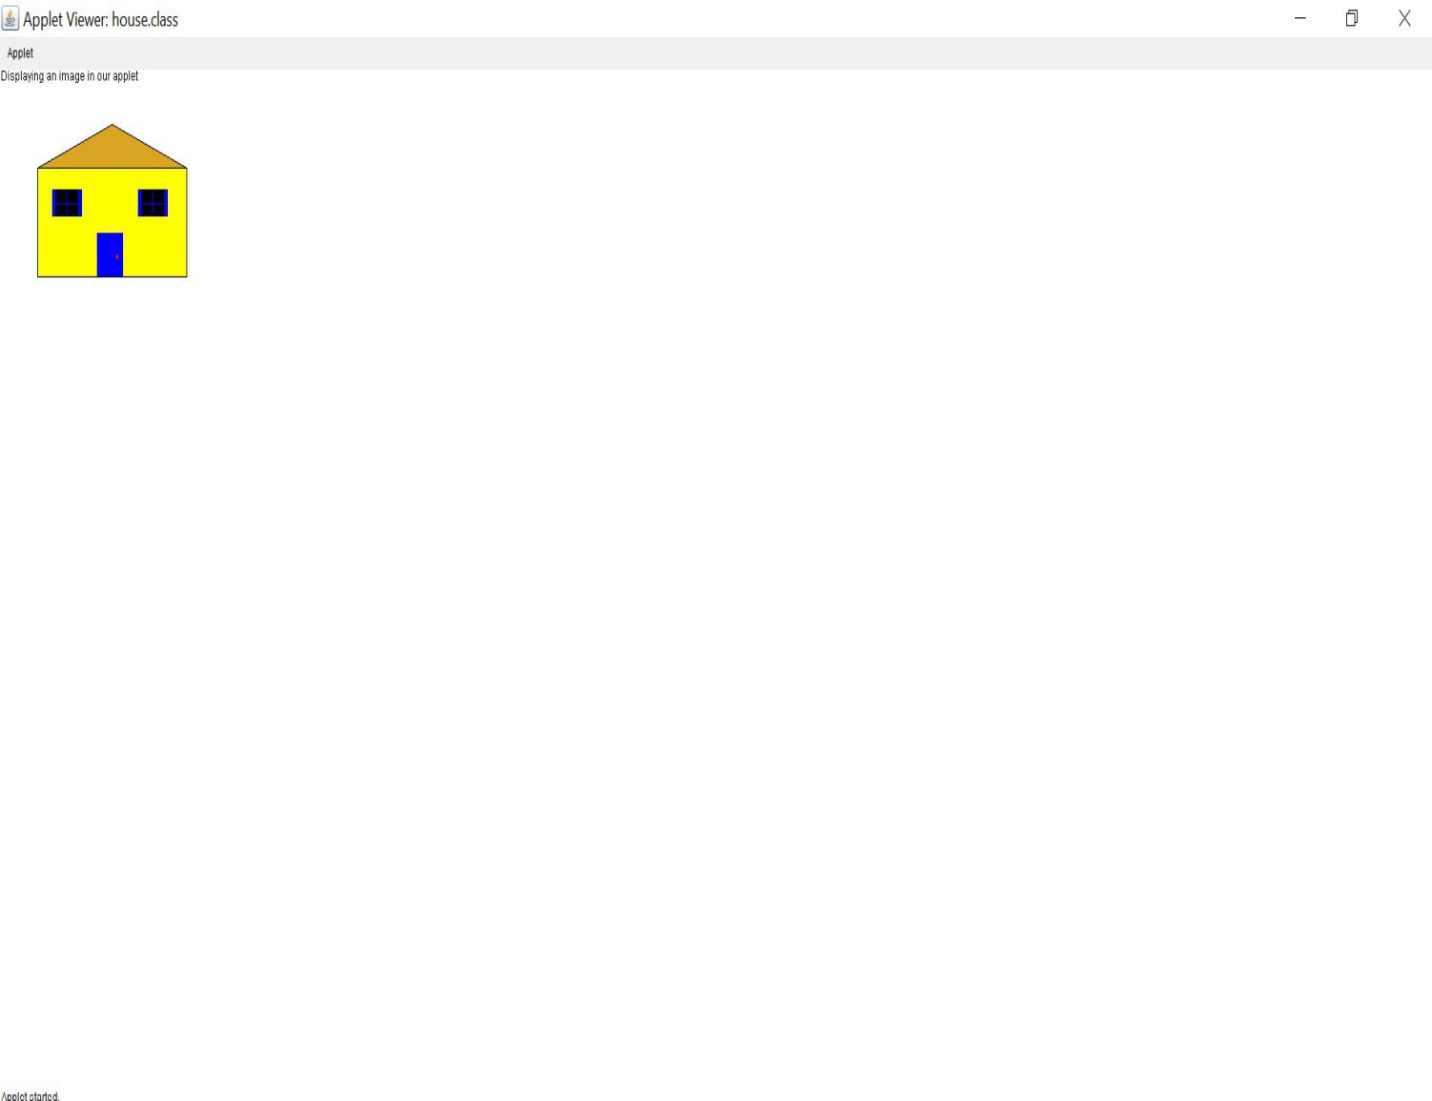

1. When the applet is loaded for the first time.

We can see here that init(),start() and paint() method is loaded automatically when an applet is loaded.

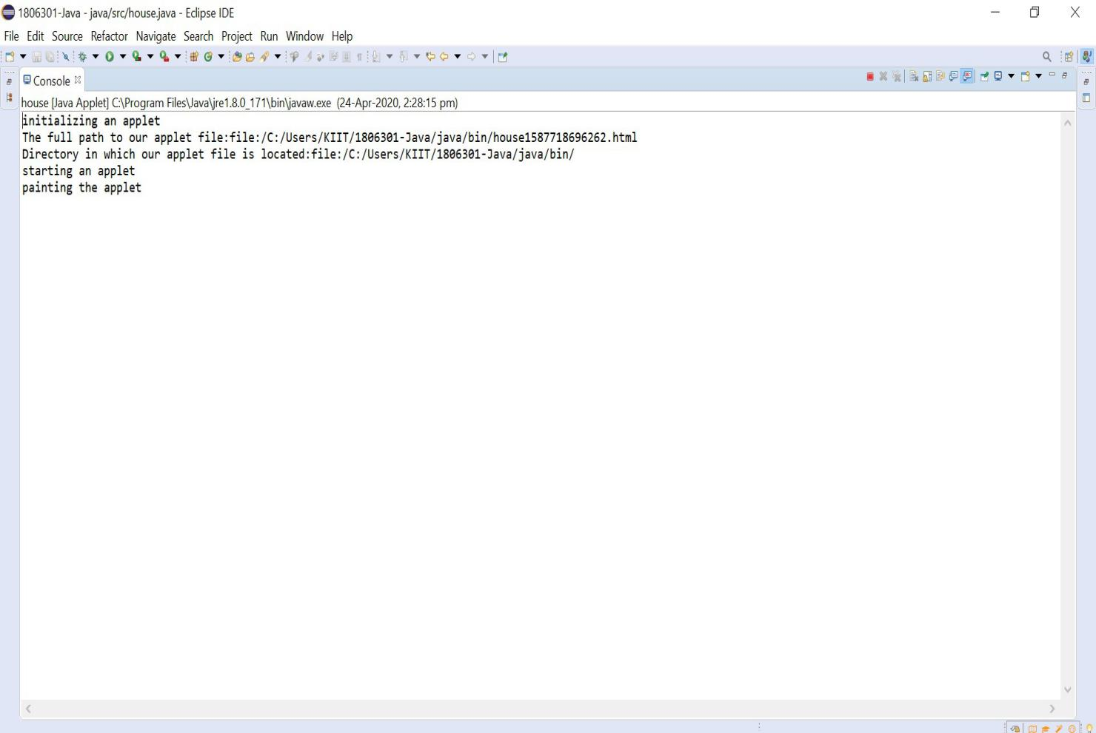

1. When the applet viewer is minimized.

Here stop() method is invoked.

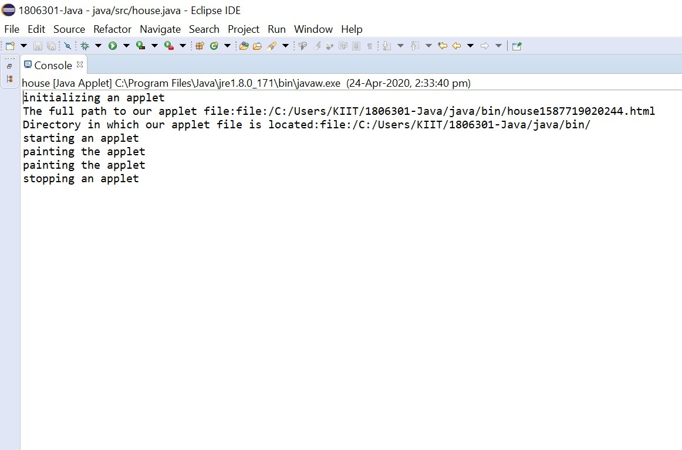

1. When the applet viewer is restored.

Here start() and paint() methods are called.

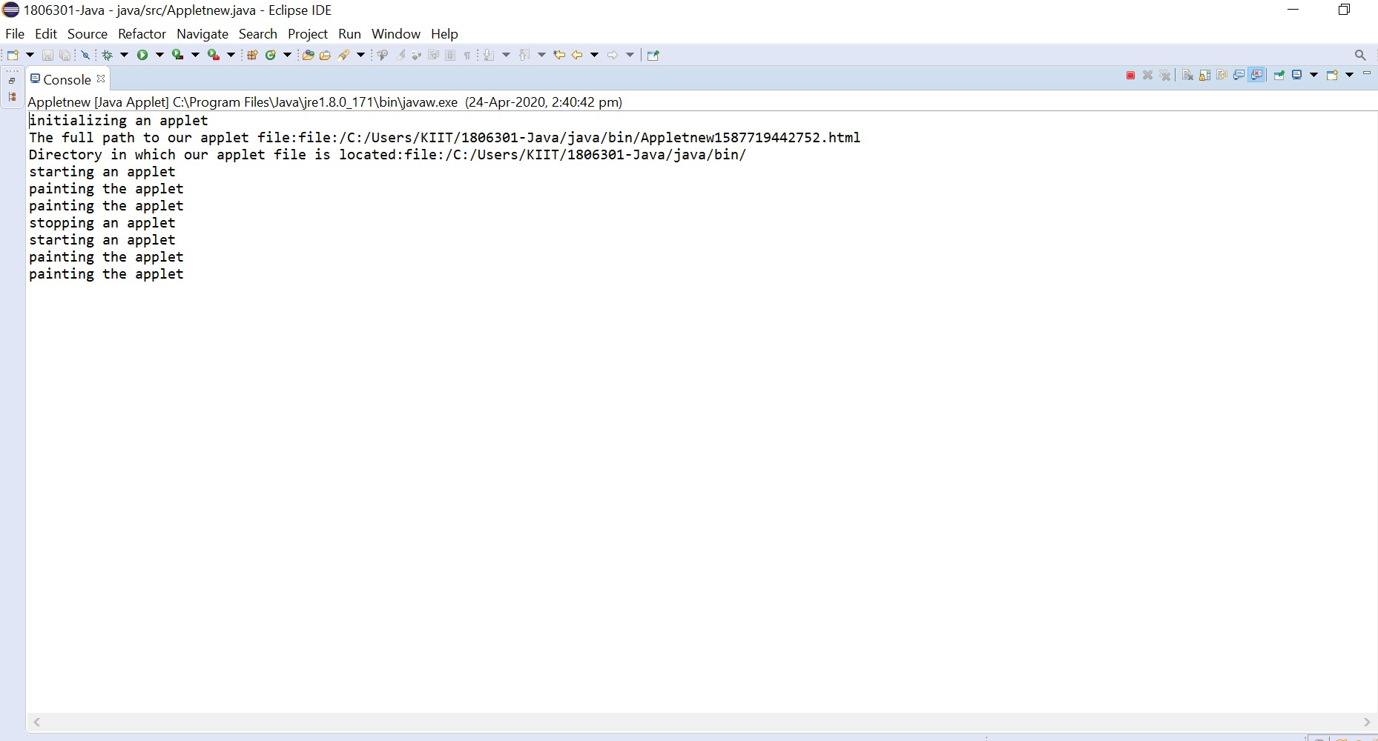

1. When the applet viewer is closed.

Here stop() and destroy() methods are called and the applet is destroyed and uploaded.

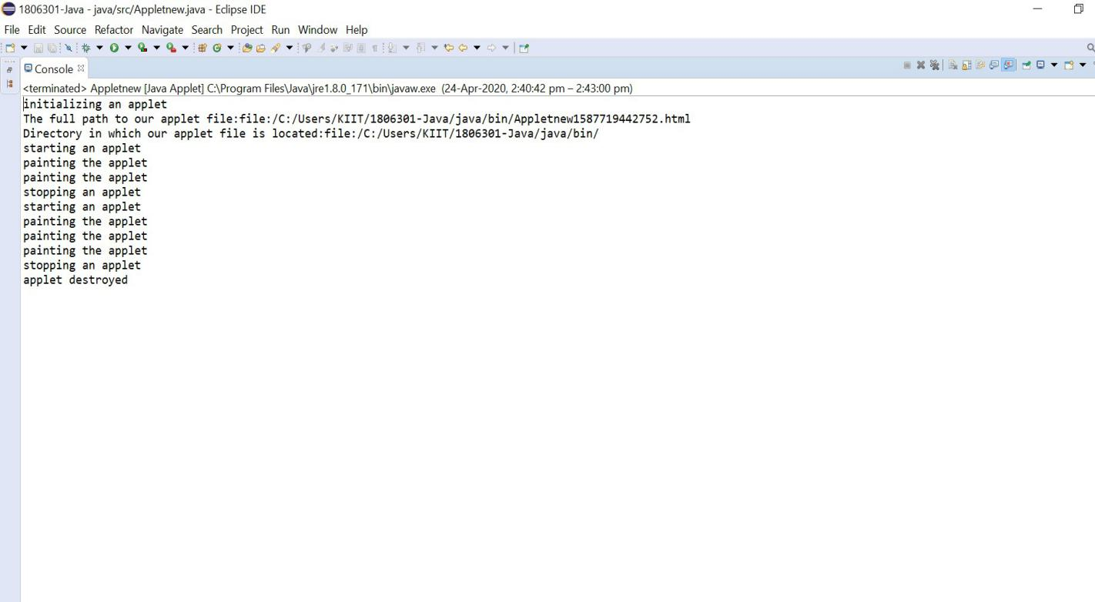

Thus from the above Example we can conclude that :-

* init() is called only once i.e when applet is loaded for the first time.
* start() and paint() methods are called as many times the applet document is viewed.
* stop() is called whenever we minimize or move to page other than page containing applet document.
* destroy() is called when we close the applet document.